**Project Design Phase-II**

**Data Flow Diagram & User Stories**

|  |  |
| --- | --- |
| Date | 26-05-2025 |
| Team ID | LTVIP2025TMID24694 |
| Project Name | *OrderOnTheGo* |
| Maximum Marks | 4 Marks |

**Data Flow Diagrams:**

A **Data Flow Diagram (DFD)** for *OrderOnTheGo* illustrates how users (customers, restaurant owners, and admins) interact with the system, and how data moves across major components like registration, cart, order management, and promotion. It also shows how each user type accesses and updates different data stores (like products, orders, and users).

Example: DFD Level 0 (Industry Standard)

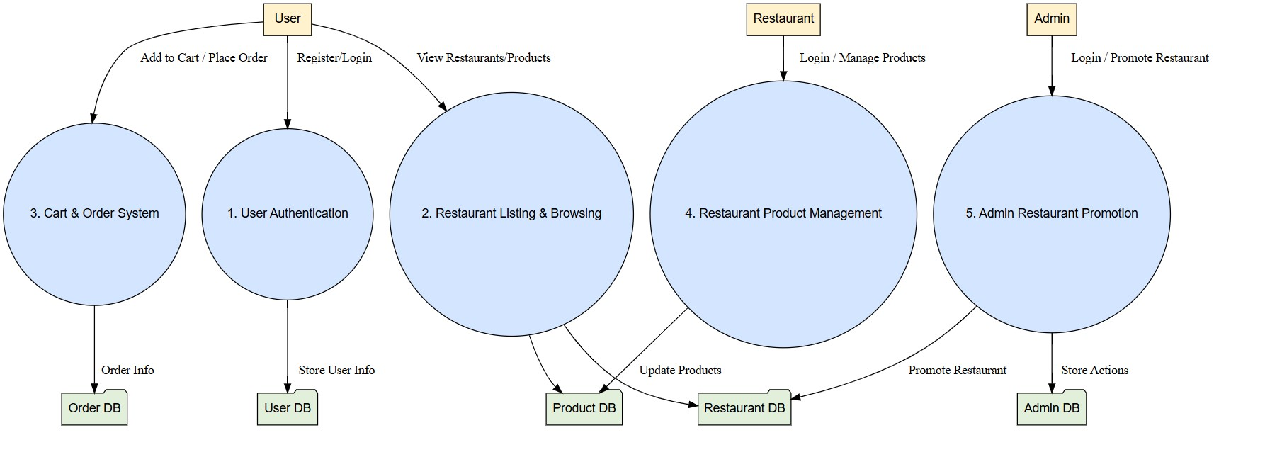

**User Stories**

**User Story Table – Freelance Finder**

|  |  |  |  |  |  |
| --- | --- | --- | --- | --- | --- |
| **User Type** | **Functional Requirement (Epic)** | **User Story / Task** | **Acceptance Criteria** | **Priority** | **Release** |
| User | User Authentication | As a user, I can sign up and log in securely. | Account created and token issued on login. | High | Sprint1 |
| User | Restaurant Browsing | As a user, I can view categories and browse restaurants. | Restaurants and promoted restaurants shown on homepage. | High | Sprint1 |
| User | Product Viewing & Cart | As a user, I can view and add food items to my cart. | Cart updates in real-time with total. | High | Sprint2 |
| User | Order Placement | As a user, I can place an order from my cart. | Order saved and visible in order history. | High | Sprint2 |
| User | Order Tracking | As a user, I can track my current and past orders. | Live and completed orders shown. | Medium | Sprint2 |
| Restaurant | Restaurant Dashboard Login | As a restaurant, I can log in and manage my dashboard. | Redirected to dashboard with product list. | High | Sprint3 |
| Restaurant | Product Management | As a restaurant, I can add/edit/delete products. | Product changes saved in database. | High | Sprint3 |
| Restaurant | Order Management | As a restaurant, I can view and update order status. | Orders update status from ‘Pending’ to ‘Delivered’. | Medium | Sprint3 |
| Admin | Admin Login | As an admin, I can log in to view restaurant stats. | Admin dashboard loads successfully. | High | Sprint4 |
| Admin | Promote Restaurant | As an admin, I can promote a restaurant to homepage. | Promoted list updates in frontend. | Medium | Sprint4 |